# Build a DRIP Modeling Dashboard

**Part I :** Data Gathering ~ 6 August 2025

**Requirement:** Create a Fantasy Football Dashboard using **player-centric data** that is **league-agnostic**. This dashboard should use only free (but reputable) data sources. The dashboard should provide a means to determine whether to start, bench or trade players based on performance data.

|  |  |
| --- | --- |
| Table | Description |
| NFL Teams | Complete master list of all NFL teams with pertinent metadata. |
| NFL Season Schedule | Complete schedule of the current season. |
| NFL Competitions | Games of the current season with locations. |
| NFL Competitors | Team match-ups with scores and other metadata. |
| NFL Leaders | High-performing players to watch. |
| NFL Player Stats | Historical player data. |
| Parameters | What-If Parameters for league scoring: |

**Visualizations:**

* **🔍 *“Weekly Start/Sit Recommendations”***
* **📈 *"Player Trend Analysis"***
* **🧠 *"Matchup Insights: Player vs. Opponent"***
* **🏥 *"Injury Impact Tracker"***
* **🔄 *"Trade & Waiver Suggestion"***
* **🧮 *"What-If Scenarios"***

**Bonus Features:**

* Dynamic filters for week, position, team
* Bookmarks or tabs for different views (Roster, Waivers, Matchups)
* Tooltips with extra stats on hover
* Alerts or flags for injuries, bye weeks, or tough matchups

Let’s Get Started!!

**Pre-Requisites:**

* Download [Power BI Desktop](https://www.microsoft.com/en-us/download/details.aspx?id=58494&msockid=13f16f1ed4bc60f9212f7ab5d5e06151) (totally free).
* Get API key from [API Sports](https://dashboard.api-football.com/) (free subscription).

# Data Sources:

# What-If Parameters:

In **Report View**, go to Modeling tab, New Parameter > **Numeric Range** and create the following ‘What-If’ parameters for different league scoring systems.

1. **Points per Reception**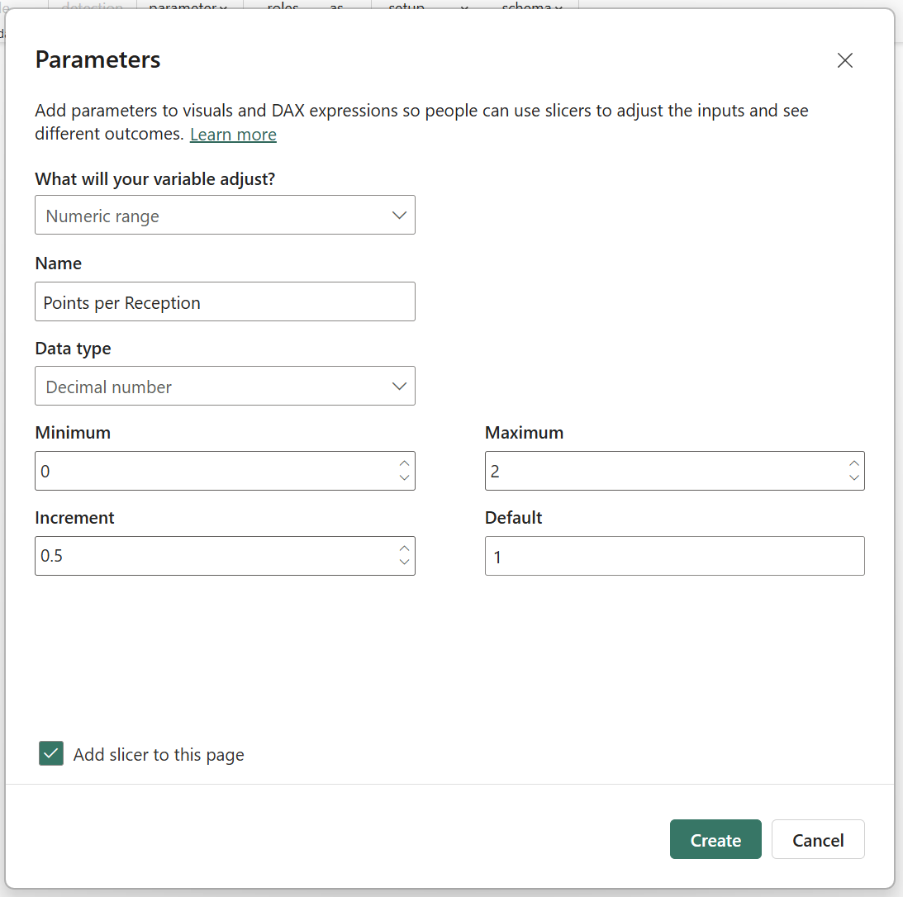
2. **Points per Rushing Yard**A screenshot of a computer

   AI-generated content may be incorrect.
3. **Points per Receiving Yard**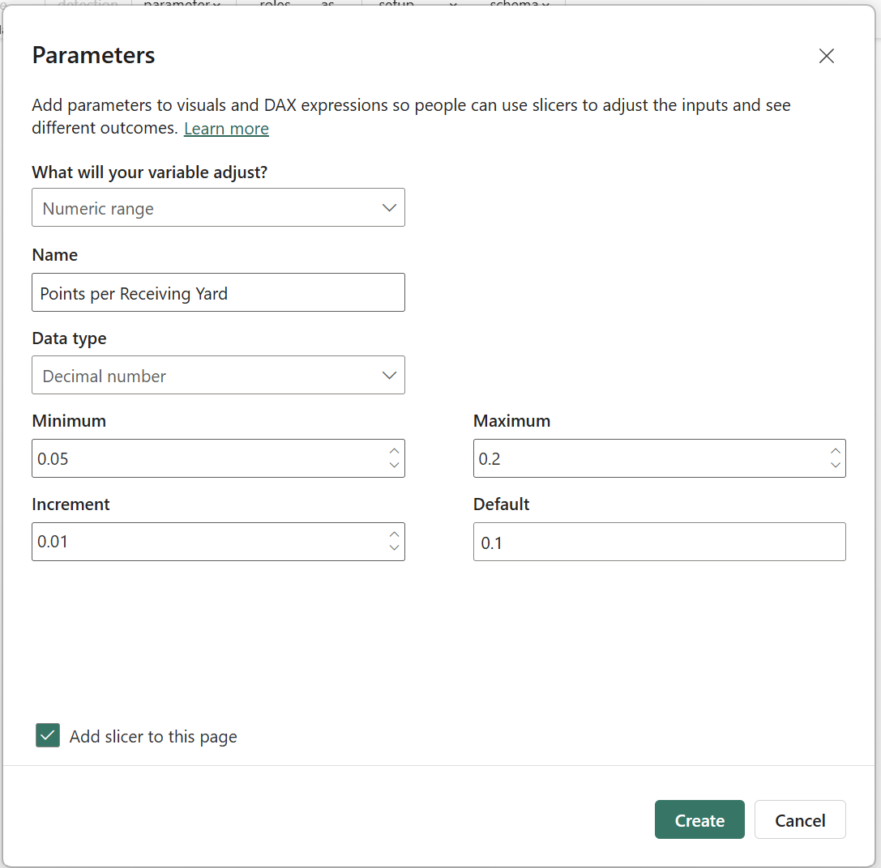
4. **Points per Passing Yard**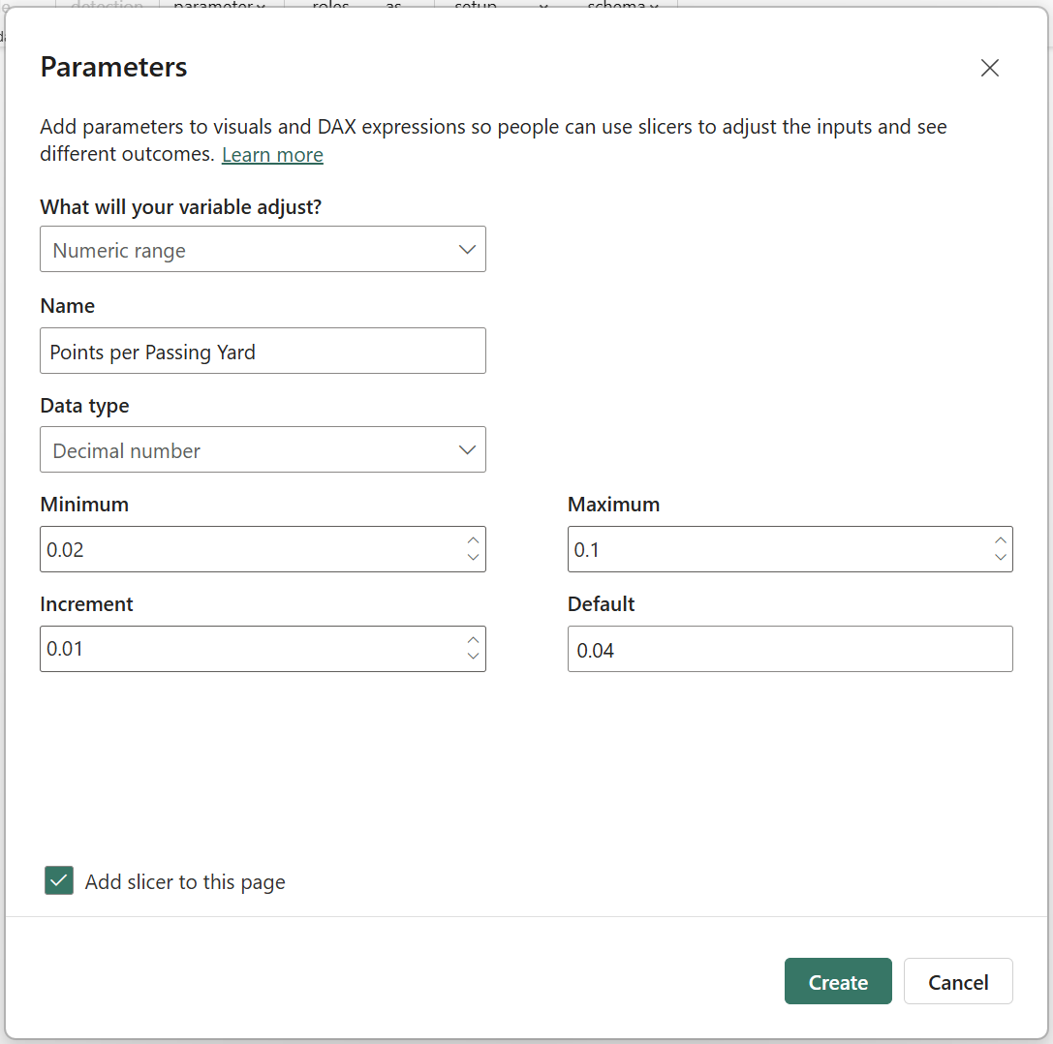
5. **Points per Touchdown**A screenshot of a computer screen

   AI-generated content may be incorrect.
6. **Penalty per Interception**A screenshot of a computer

   AI-generated content may be incorrect.
7. **Penalty per Fumble**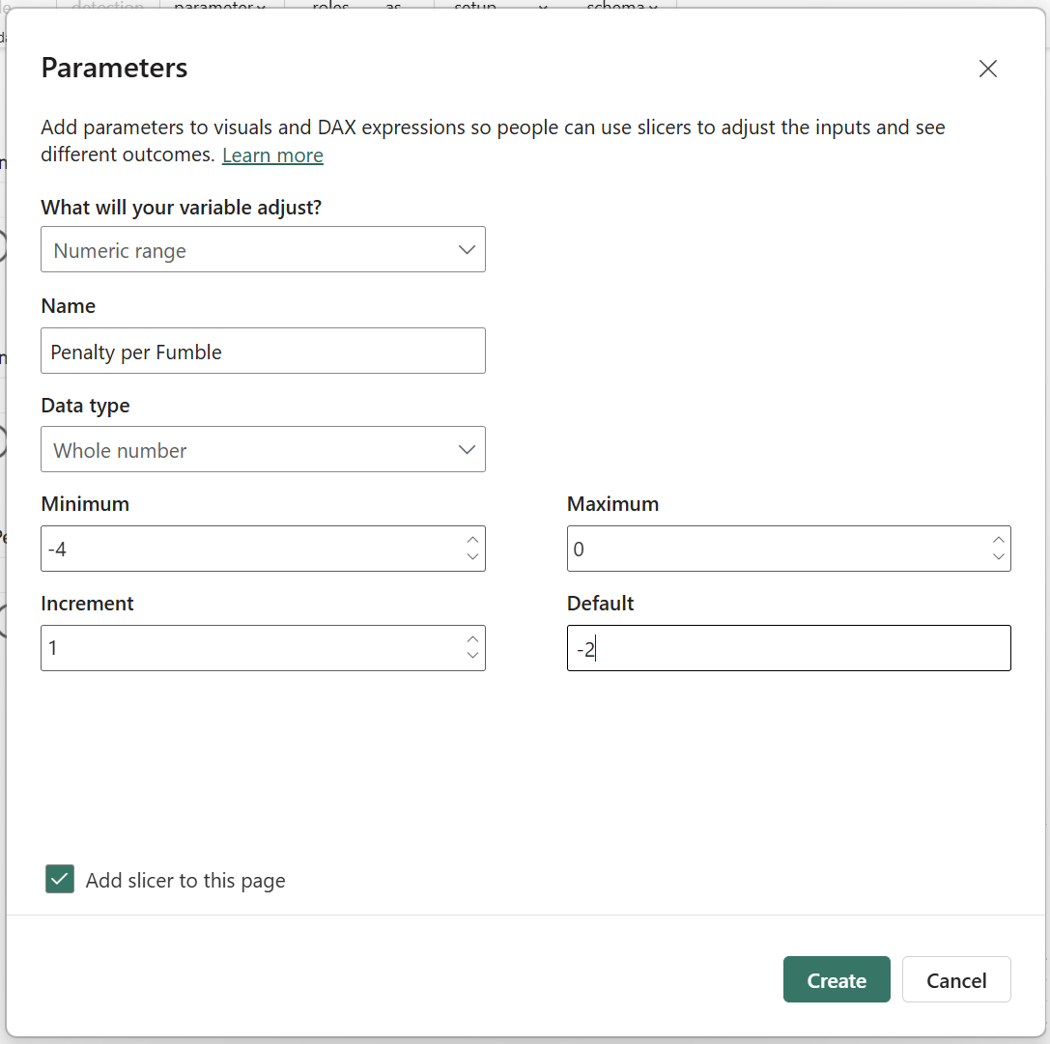

You should now see seven slicers on your report – one for each What-If parameter. Arrange these along the left side of your dashboard.

# Measures for Fantasy Points:

1. **Fantasy Points:** In **Report View**, expand the Data pane, then right-click on the NFL Leaderstable > **New Measure** and copy/paste the following DAX then copy/paste the following DAX:

|  |
| --- |
| Fantasy Points =  SUMX(  'NFL Leaders',  [Rushing Yards] * 'Points per Rushing Yard'[Points per Rushing Yard Value] +  [Receiving Yards] * 'Points per Receiving Yard'[Points per Receiving Yard Value] +  [Receptions] * 'Points per Reception'[Points per Reception Value] +  [Touchdowns] * 'Points per Touchdown'[Points per Touchdown Value] +  [Passing Yards] * 'Points per Passing Yard'[Points per Passing Yard Value]  ) |

1. **Start/Sit Recommendation:** Right-click the NFL Leaders table again and create another measure with this DAX:

|  |
| --- |
| StartSitRecommendation =  SWITCH(  TRUE(),  [Fantasy Points] >= 15, "Start",  [Fantasy Points] >= 8, "Borderline",  [Fantasy Points] < 8, "Sit",  BLANK()  ) |

# Start/Sit Recommendation Table:

* In **Report View**, expand Visualizations pane and select the **Table** visual.  
  NOTE: Make sure nothing is selected before you do this, otherwise it will convert whatever you have selected to a table!  
  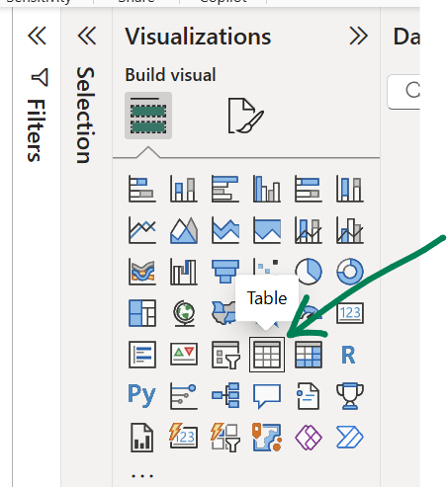
* On your new table, select the following fields:

|  |  |  |
| --- | --- | --- |
|  |  |  |

* **Conditional Formatting:** 
  + With the table still selected, go to the Visualizations pane > Columns > Recommendation (drop-down) > Conditional Formatting > **Background Color:**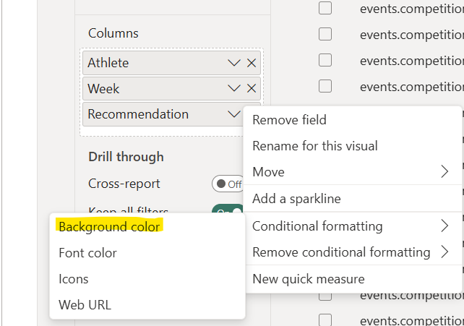
  + Apply the following rules:  
    A screenshot of a computer

    AI-generated content may be incorrect.
* **Player Profile Link**
  + On the Data pane > NFL Leaders table > select the **Athlete HREF** text (NOT the checkbox!)  
    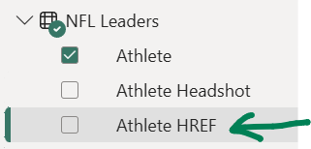
  + On the ribbon bar > set the Data Category (center) to **Web URL  
    A screenshot of a computer

    AI-generated content may be incorrect.**
  + With your table visual selected, expand the Visualizations pane > Format tab (paintbrush icon) > Visual > Cell elements > Apply settings to > Series > **Athlete,** and toggle on the **Web URL**  
    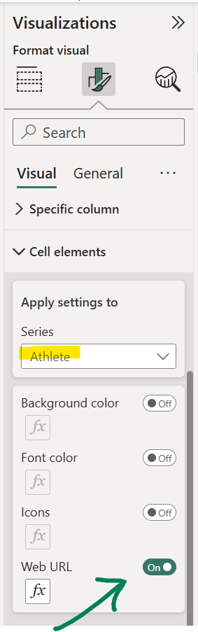

# Player Tool-tip:

Create a ‘Tooltip’ page for use in the dashboard. This will dynamically display player stats when you hover over the player’s name on the dashboard.

1. **Create Tooltip Page**
2. **Create Title with Player Name and Jersey**
3. **Create Table with Player Picture and Stats**
4. **Enable Tooltip on Visual**